**DR CNRS Vincent Vignal**

Zdjęcie ☺

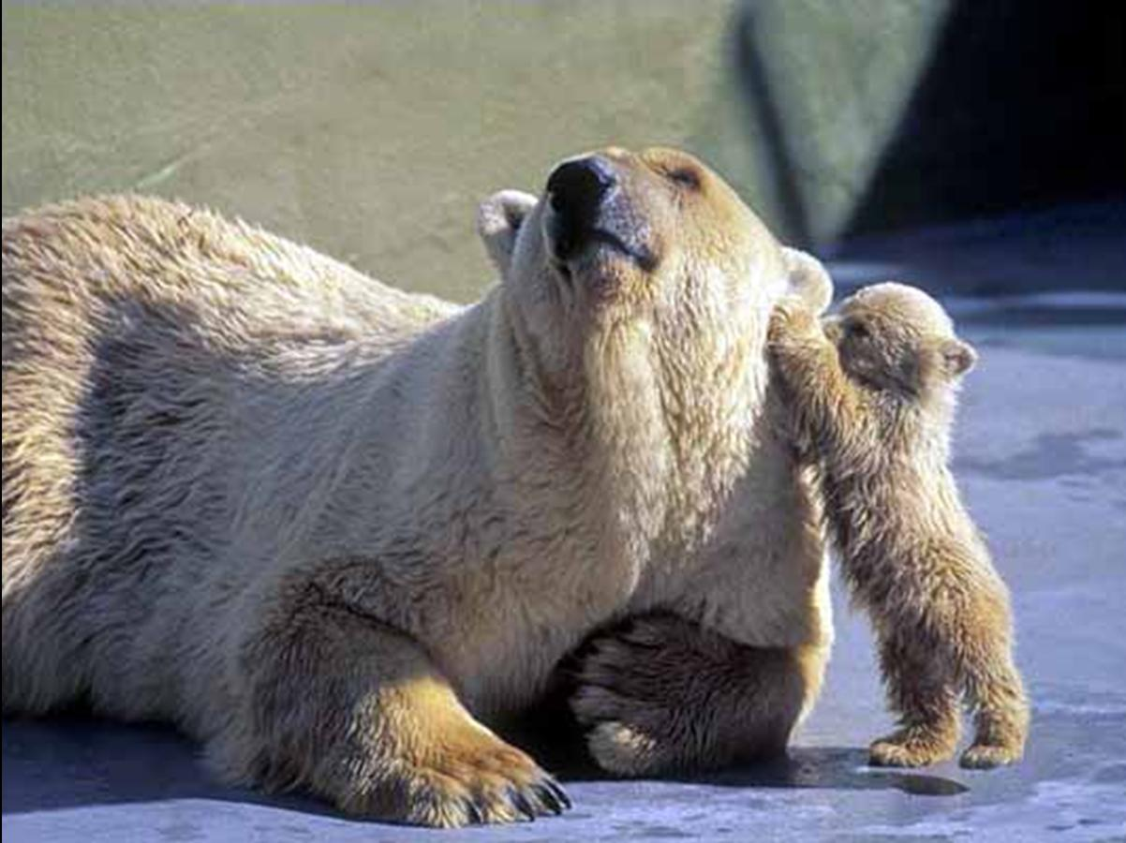

**Stanowisko:** Visiting Professor

**Kontakt:** vincent.vignal@u-bourgogne.fr

**Pełnione funkcje:** (np. pełnomocnik Dziekana ds. BHP, Prodziekan, Przewodniczący Komisji Rekrutacyjnej itp.) / Visiting professor at AGH

**Aktywność naukowa:** Corrosion of metals and alloys, Surface mechanics, metallurgy, relationships between microstructure, surface stress/strain and corrosion

**Aktywność dydaktyczna**: 60 hours per year, Thematics : ‘Selected Problems in Surface Engineering’ and ‘Numerical Simulation and Experimental Methods for Mechanical Characterization of Solid Surfaces’

**Publikacje za stanie 5 lat**: (najważniejsze publikacje, max.10)

H. Krawiec, V. Vignal, E. Schwarzenboeck and J. Banas, *Role of plastic deformation and microstructure in the micro-Electrochemical behaviour of Ti-6Al-4V in sodium chloride solution*, **Electrochimica Acta**, 104, pp. 400-406 (2013).

V. Vignal, D. Ba, H. Zhang, F. Herbst and S. Le Manchet, *Influence of the grain orientation spread on the pitting corrosion resistance of duplex stainless steels using Electron Backscatter Diffraction and Critical Pitting Temperature test at the microscale*, **Corrosion Science**, 68, pp. 275-278 (2013).

V. Vignal, H. Krawiec, O. Heintz and D. Mainy, *Passive properties of lean duplex stainless steels after long-term ageing in air studied using EBSD, AES, XPS and local electrochemical impedance spectroscopy*, **Corrosion Science**, 67, pp. 109-117 (2013).

H. Krawiec, Z. Szklarz and V. Vignal, *Influence of applied strain on the microstructural corrosion of AlMg2 as-cast aluminium alloy in sodium chloride solution*, **Corrosion Science**, 65, pp. 387-396 (2012).

H. Krawiec, S. Stanek, V. Vignal, J. Lelito and J.S. Suchy, *The use of micro-capillary techniques to study the corrosion resistance of AZ91 magnesium alloy at the micro-scale*, **Corrosion Science**, 53(10), pp. 3108–3113 (2011).

H. Amar, V. Vignal, H. Krawiec, C. Josse, P. Peyre, S.N. da Silva and L.F. Dick, *Influence of the microstructure and laser shock processing (LSP) on the corrosion behaviour of the AA2050-T8 aluminium alloy*, **Corrosion Science**, 53(10), pp. 3215-3221 (2011).

**Inne:** np. członkowstwo w organizacjach naukowych Active member of the Electrochemical Society (ECS), Active member of the International Society of Electrochemistry (ISE), Active member of the Centre Français de l’AntiCORrosion (CEFRACOR).